This application was written in WPF(C#) with MVVM design pattern. I thought it is easy to demonstrate the result. I also have many years of experience in different kinds of skills, including asp.net mvc, WCF, entity framework, MEF, jquery, angular, linq, html, css, MSSQL, Bootstrap, ajax and so on. If you want to know more about my knowledge and my skill, I appreciate if you would visit my personal project in the following link: <http://www.codeproject.com/Articles/1074801/Cool-Privilege-Control-System-Part-ASP-NET-MVC>, Thanks.

**Program 1:**

1. **Base Information**

This program can list all text files in the lowest depth folder based on the specified path.

1. If there are more than one folder in the same depth, system will show all text files which are contained in these folders.
2. If there is no text file in the lowest depth folder, system will pop up a message to the user.
3. Validation:

* Path cannot be empty.
* Determine whether the path is a valid path.

1. **How to use**
2. Input the specified path or select the path via folder browser.

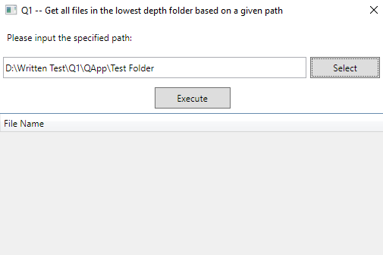

1. Click “Execute” button.

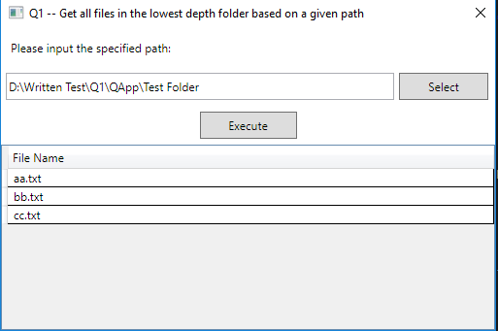

**Program 2:**

1. **Formula**

X Train 1 Speed  
 -------------------------------------- = -------------------------------------------  
 Distance between the trains (Train 1 Speed + Train 2 Speed)

X = Train 1 distance

Y Train 2 Speed  
 -------------------------------------- = -------------------------------------------  
 Distance between the trains (Train 1 Speed + Train 2 Speed)

Y = Train 2 distance

Train 1 mins = Train 1 distance/ Train 1 Speed *60

Train 2 mins = Train 2 distance/ Train 2 Speed *60

Average mins = (Train 1 mins + Train 2 mins)/2

Besides, in order to fix the rounding issue, I add the remaining number to the faster train.  
E.g.   
Distance: 10 miles  
Train 1 distance: 5.24 miles  
Train 2 distance: 4.75 miles   
(10 - 5.24 - 4.75)>0!!!  
Train 1 is faster than Train 2, so change Train 1 distance from 5.24 miles to 5.25 miles.

1. **How to use**
2. Input Distance, Train 1 speed and Train 2 speed.

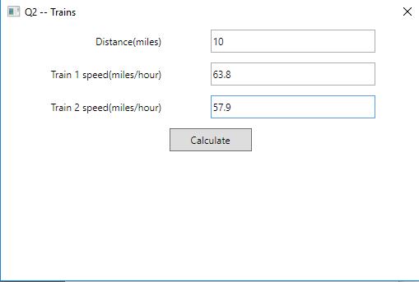

1. Click “Calculate” button.

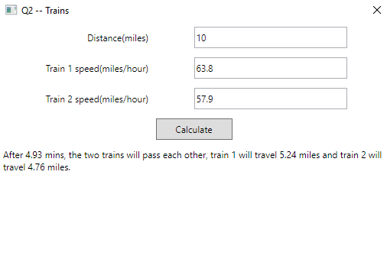

**Program 3:**

1. **Base Information**
   1. When the program start, System will load a txt file which is placed in “Files” folder as Dictionary, and its name is “Dictionary.txt”.

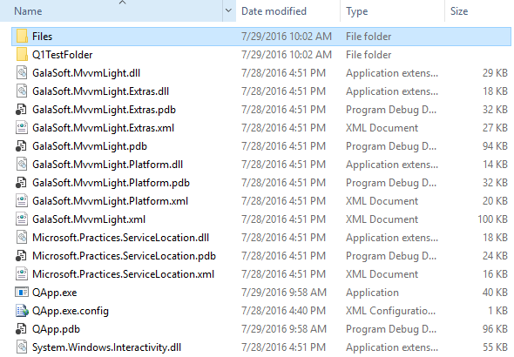

You can easily add any English words into the dictionary, and use “|” to split each word.

E.g.   
Start|Burst|art|star|I|am|developer

* 1. The comparison is case-insensitive. Even if you input “startburst” or “StartBurst”, the results are the same. 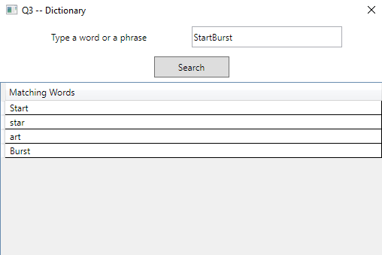

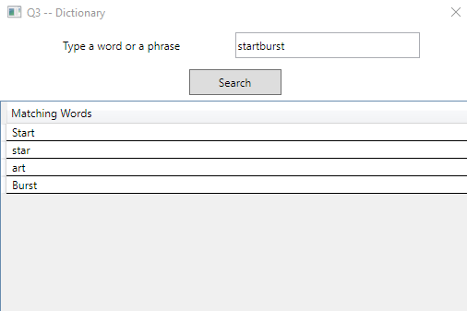

1. **How to use**
   1. Type a word or a phrase.

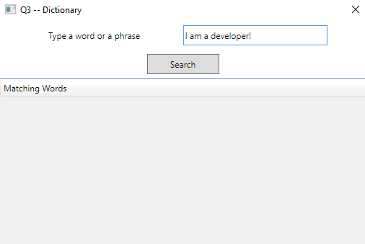

* 1. Click “Search” button.

